Photress

Use-Case Specification: Manage galleries

Version <1.1>

Revision History

|  |  |  |  |
| --- | --- | --- | --- |
| **Date** | **Version** | **Description** | **Author** |
| 21.10.2013 | <1.0> | First version of Manage gallery settings | Benny Görzig |
| 31.10.2013 | <1.1> | Changed name to “Manage galleries” Added Mockup Added Narration | Benny Görzig |
|  |  |  |  |
|  |  |  |  |

Table of Contents

1. Manage galleries 4

1.1 Brief Description 4

2. Flow of Events 4

3. Special Requirements 4

4. Preconditions 4

5. Postconditions 4

6. Extension Points 4

7. Mockup 5

8. Narration 6

Use-Case Specification: Manage galleries

# Manage galleries

## Brief Description

The Use Case “Manage galleries” is accessible for the users “Admin of own gallery” and “Admin of hosted gallery”. They will be able to create, read, update and delete their different galleries (CRUD). It is important to know that a gallery contains an image-pool. Therefore it manages the view of images on the website from its pool. Apart from deleting, changing gallery settings will not affect the pool.

# Flow of Events

# E:\SoftwareEngineering\TeamDrive\Spaces\Projekt 'Photress'\Dokumente\AD - Manage Galleries.emf

# Special Requirements

N.a.

# Preconditions

Create: The actor has to fill out the required information for the settings of a gallery.

Read: The actor has to have galleries which he can manage. The actor has to be the owner of the chosen

gallery.

Update: The actor has to fill out required information of a gallery and this gallery has to exist. The actor has to be the owner of it.

Delete: There has to exist a gallery which the actor is owner of.

# Postconditions

Create: The actor has a new gallery with a compilation of gallery settings.

Read: The actor sees the settings for a specific gallery or a list of gallery settings.

Update: The actor has an updated version of his gallery settings for a specific gallery. The changed settings

are applied.

Delete: Deletes the gallery, the settings and all the pictures which the image-pool contains.

# Extension Points

N.a.

# Mockup

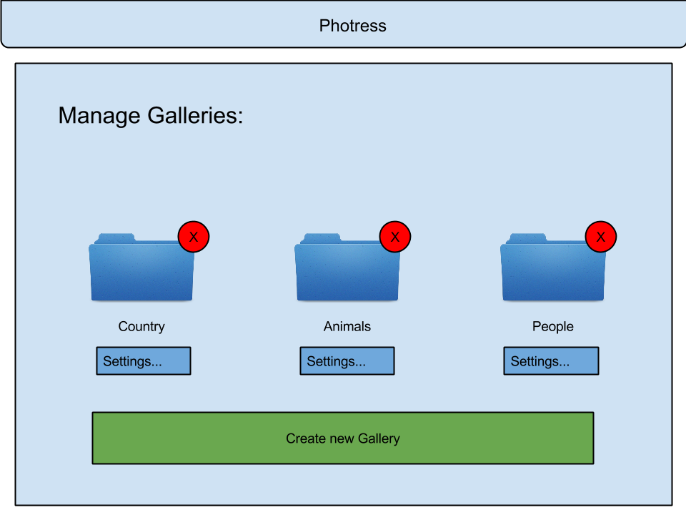

# Narration

Feature: Manage_galleries_(CRUD)

A registered user and an administrator of a selfhosted instance have the

possibility to manage their galleries respectively the galleries owned by other

users but hosted on her/his instance. This includes beside the CRUD-functionalities

a list of all assigned galleries respectively of all galleries run of one’s instance.

Scenario: Listing galleries

Given I am logged in as user

And I already created a gallery

And I navigated to the gallery list

When the page becomes display

And all data has been loaded

Then "galleries_list" contains a list of my galleries

Scenario: Listing galleries as owner of a instance

Given I am hosting my own instance

And I logged in successfully

And anybody using my instance (or myself) created a gallery

And I navigated to the gallery list

When the page becomes display

And all data has been loaded

Then "galleries_list" contains a list of all galleries hosted on my instance